
Belmont City College
Semester 1 Examination, 2013
Question/Answer Booklet

PHYSICS
Stage 2
Name: ___________________________________
Teacher: BRADBURY

Time allowed for this paper
Reading time before commencing work: Ten minutes
Working time for paper: Two and a half hours
Material required/recommended for this paper
To be provided by the supervisor
This Question/Answer Booklet
Physics Formulae, Constants and Data Sheet
To be provided by the candidate
Standard Items: Pens, pencil, eraser, correction fluid, ruler, highlighter
Special Items: MATHOMAT and/or Mathaid, drawing compass, protractor, set square and calculators satisfying the conditions set by the Curriculum Council for this subject.
Important note to candidates
No other items may be taken into the examination room. It is your responsibility to ensure that you do not have any unauthorised notes or other items of a non-personal nature in the examination room. If you have any unauthorised material with you, hand it to the supervisor before reading any further.
Structure of this paper

Section | Number of questions | Suggested Time (minutes) | Number of questions to be answered | Marks available | Percentage of exam
A: Short Answers | 10 | 55 | ALL | 41 | 37
B: Problem Solving | 5 | 78 | ALL | 57 | 52
C: Comprehension and Data Analysis | 1 | 17 | ALL | 12 | 11
 |  |  | Total | 110 | 100%
Instructions to candidates
- Write your answers in this Question/Answer Booklet.
- Working or reasoning should be shown clearly when calculating or estimating answers.
- All answers must be to three (3) significant figures unless stated otherwise.
- You must be careful to confine your responses to the specific questions asked and to follow any instructions that are specific to a particular question.
- Spare pages are included at the end of this booklet. They can be used for planning your responses and/or as additional space if required to continue an answer.
- Planning: If you use the spare pages for planning, indicate this clearly at the top of the page.
- Continuing an answer: If you need to use the space to continue an answer, indicate in the original answer space where the answer is continued, i.e. give the page number.
Fill in the number of the question(s) that you are continuing to answer at the top of the page.

Section A: Short answers
[41 Marks]
This section has ten (10)questions. Answer all questions. Write your answers in the space provided.
Suggested working time: 55 minutes

1. A cyclist at the races completes 3 laps of a 420 m circular track in 2 ½ minutes.

a) Determine the cyclist’s average speed in ms⁻¹. [2 marks]

b) Determine the cyclist’s average velocity. [2 marks]

2 In 1986 a nuclear reactor exploded at Chernobyl in the Ukraine, sending a cloud of radioactive material over several European countries, and causing radiation levels to rise above normal background levels. Most of the radioactive material was iodine-131 with a half-life (t_{1/2}) of 8 days. Also released were caesium-137 and caesium-134, with half-lives of 2 years and 30 years respectively.

a) What is meant by normal background radiation? [2 marks]

b) How is the caesium-137 nucleus similar to the caesium-134 nucleus? How are they different? [2 marks]

c) Which isotope of caesium would you expect still causes most concern today and why? [2 marks]

3. A falling skydiver with a mass of 80.0 kg experiences an air resistance of 510 N. Calculate the acceleration of the skydiver. [3 marks]

4. In the North of WA there is a design for a power station which uses the rising and falling sea tides to generate electricity. During each high tide the sea water storage area can hold 3.56 x 10¹³ kg of the salt water. When the tide recedes (low tide) there is an average height difference of 2.12m. The tidal power station is only 20% efficient.

a) Calculate the amount of energy the station produces from a single high tide. [3 marks]

b) If the change in tide occurs over 6.00 hours, what is the power produced from the tidal power station? [2 marks]

5. Just as traffic lights turn green, a waiting car starts off with a constant acceleration of
6.00 ms⁻². At the instant the car begins to accelerate, a truck with a constant velocity of
21.0 ms⁻¹ passes in the next lane.

a) How far will the car travel before it overtakes the truck? [3 marks]

b) What is the velocity of the car at the instant it overtakes the truck? [2 marks]

6. The elastic of a child’s crossbow is pulled back and held firmly so that it makes an angle of 45.0º with the tail of the arrow. The tension in each side of the elastic is 65.0 N, (assume a constant value).
45º
45º

a) Calculate the total force acting on the arrow and give its direction. [2 marks]

b) If the arrow has a mass of 250 g and the acceleration of the arrow by the elastic takes place over a distance of 15.0 cm before leaving the crossbow, calculate the maximum velocity attained by the arrow.(If you couldn’t do part a) of this question, use a value of 90.0 N for net force). [3 marks]

7. If a car travels the length of 10 000 $5 notes in the time it takes to watch a TV commercial, estimate the car’s velocity in km h⁻¹. [2 marks]

8. The graph below shows how the displacement of a toy train moving in a straight line varies over a period of time.
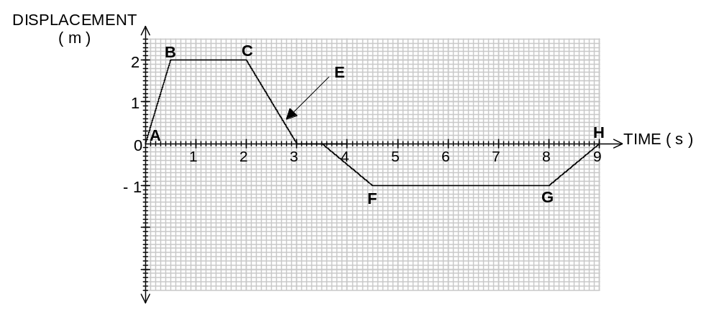

a) What is the maximum speed attained by the train? [2 marks]

________________

b) Describe the motion of the train in section: [2 marks]

(i) BC

______________________________________________________________________

(ii) E

______________________________________________________________________

c) What is the total length of track used by the train in the above journey? [2 marks]

___________________

9. Melinda is playing cricket for her school and, in a match, swings her new 2.20 kg bat forward to strike a 0.350 kg ball that is being bowled towards her at 22.5 m s⁻¹. Her bat is moving towards the ball at a speed of 8.50 m s⁻¹ before it strikes it and the bat slows to a speed of 0.300 m s⁻¹ forwards after the ball is hit.

8.50 m s⁻¹
22.5 m s⁻¹

Calculate the speed with which the ball leaves the bat after it has been hit. [3 marks]

10. During filming of The Greatest Escape, a stuntsperson leaps off a tall building to a safety net 1.35x10²m below. How long will the stuntperson take to reach the net? [2 marks]

END OF SECTION A
Section B: Problem-solving
[57 marks]

This section has five (5) questions. Answer all questions in the spaces provided.
Suggested working time: 78 minutes.

11. [11 marks]

A roller coaster at a festival is set up by a carriage being hauled to the top by an electric motor. The mass of the carriage and the people is 505 kg and the vertical height is 31.0 m

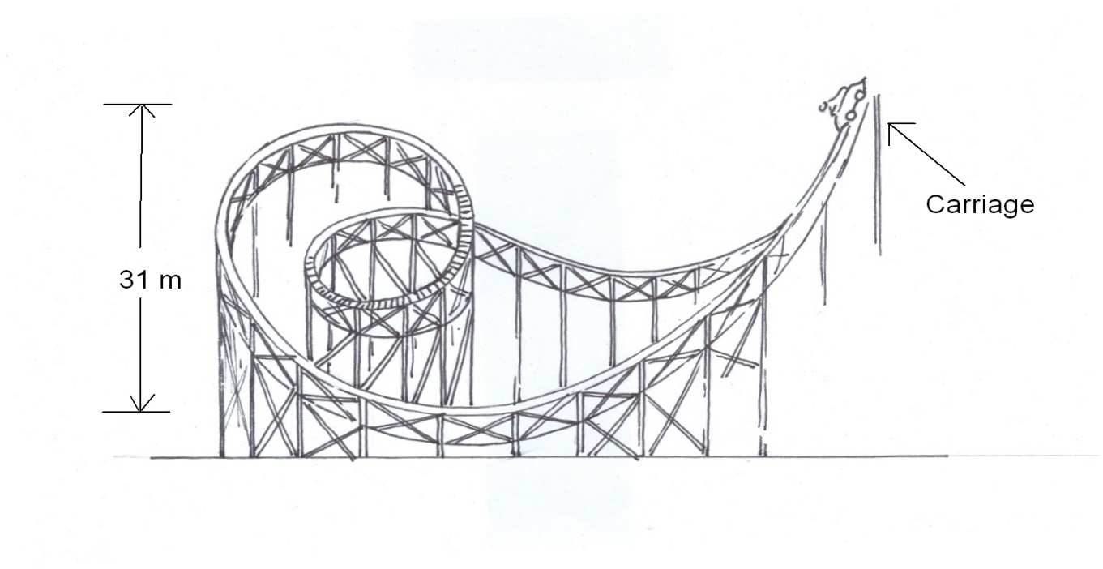
A
B
C

a) Calculate the potential energy of the carriage at the beginning of the ride (Point A).
[2 marks]

b) What is the speed of the car when it reaches the bottom (Point B) ? [3 marks]

c) What is the momentum of the carriage at Point B? [2 marks]

d) The designers of the roller coaster realise that Point C is at the wrong height. If the designers want the speed at point C to be 3.00 ms⁻¹, calculate the new height of point C relative to the ground. Ignore friction in your calculations. [4 marks]
12. [12 Marks]

a) Carbon-14 is formed in the upper atmosphere by the interaction of nitrogen and cosmic rays that results in the N-14 atom of 7 protons and 7 neutrons absorbing a high speed neutron and ejecting a proton, hence being transformed into a C-14 atom of 6 protons and 8 neutrons.
Living creatures take in C-14 as part of the carbon in their CO₂ intake (plants) or food intake (animals).
The decay curve for a typical sample of C-14 is given below.
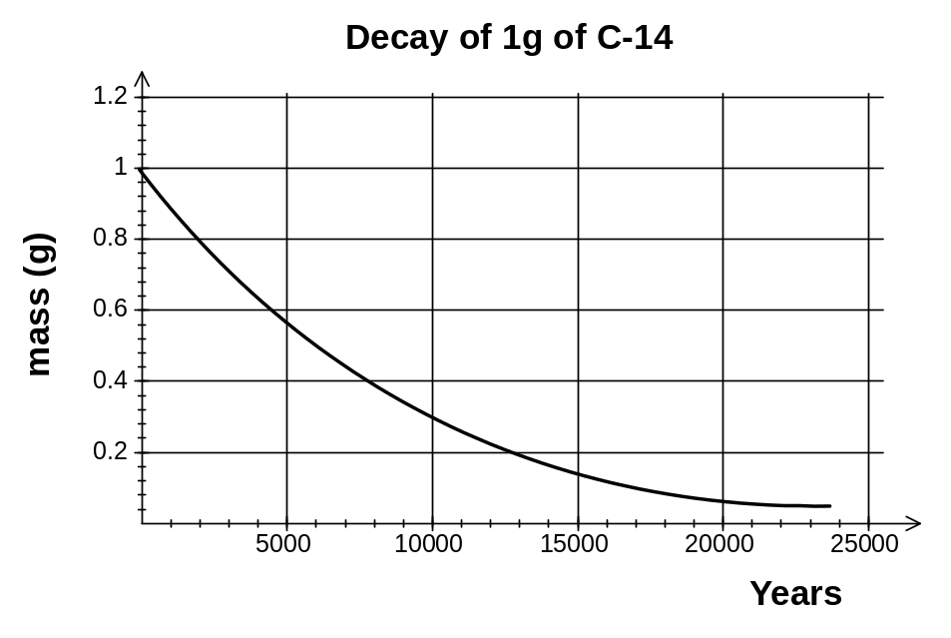

- i) Write an equation to show the process involved in the formation of C-14. [2 marks]

ii) From the graph above estimate a value for the half-life of C-14. Show clearly on the graph how you made this estimate [2 marks]

iii) Based on your estimate of half-life for C-14, estimate the age of a wooden spoon found in an Egyptian tomb if one gram of carbon from the spoon yields 117 counts on a Geiger tube in one hour, given that a the same amount of carbon from a similar modern spoon has an activity of 0.26 Bq. [2 marks]

iv) Explain why it is necessary to use the spoon from the tomb to date the age, rather than gold or rock carvings found together with the spoon. [2 marks]

b) Calculate the mass defect of a Lithium-7 atom. You may do the calculations and give your answer in either atomic mass units or kilograms, using the following information and/or the information in your formula and data sheet. [4 marks]
Mass of neutron = 1.00867 u
Mass of proton = 1.00727 u
Mass of electron = 5.49 x 10⁻⁴ u
Mass of hydrogen-1 atom = 1.00783 u
Mass of Li-7 atom = 7.01601 u

13. [9 marks]

Luke and Anthony are part of the local cricket club. Luke is bowling the cricket ball, which has a mass of 0.160 kg. The ball is travelling at a horizontal velocity of 108 kmh⁻¹ when it strikes Anthony on the head. The ball is brought to rest in 0.500 x 10⁻³ s. Luckily Anthony is wearing a safety helmet.

a) What is the total impulse the ball delivers to Anthony’s helmet? [2 marks]

b) What was the ball’s acceleration while in contact with Anthony’s helmet? [2 marks]

c) What is the average force the ball exerts on Anthony’s helmet? [2 marks]

d) What work was done on the ball by the helmet to bring it to a halt? [3 marks]

14. [11 marks]
A girl on a sledge slides down a slope at the snowfields. The total mass of the girl and the sledge is 105 kg. The record of her journey from A to D is recorded on a combined stopwatch-speedometer attached to the sledge. The readings of this instrument at positions A , B , C and D are shown in the table below.

A
B
D
C
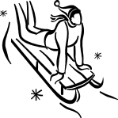

Position | A | B | C | D
Time (s) | 0 | 6.00 | 10.0 | 15.0
Speed (ms⁻¹ ) | 0 | 8.00 | 8.00 | 0


a) Sketch a speed versus time graph for the sledge’s journey from A to D on the axes provided below. [2 marks]

b) Calculate the average deceleration and hence retarding force acting on the sledge during
stage CD. [3 marks]

c) Use the graph to calculate the distance travelled from A to D. [3 marks]

d) If stage BC is at an angle of 12.0° to the horizontal, calculate the frictional force acting on the sledge during that stage. [3 marks]

14. [14 marks]
(a) In a thermal nuclear reactor, induced fission is caused by the U–235 nucleus capturing a neutron, undergoing fission and producing more neutrons. Which one of the following statements is true? (Circle the correct answer).

A To sustain the reaction a large number of neutrons is required per fission.
B The purpose of the moderator is to absorb all the heat produced.
C The neutrons required for induced fission of U–235 should be slow neutrons.
D The purpose of the control rods is to slow down neutrons to thermal speeds.
[1 mark]

(b) An unstable isotope of uranium may split into a caesium nucleus, a rubidium nucleus and some neutrons in the following process.

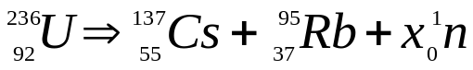

(i) Determine the value of X, - i.e. determine how many neutrons are produced in the above process.
[1 mark]

(ii) Calculate the energy, in Mev and in Joules, which is released in the above process, given
the following nuclear masses together with data from the Formula and Constants Sheet. [4 marks]
mass of a neutron = 1.00867 u
mass of a nucleus of Cs 137 = 136.87688 u
mass of a nucleus of Rb 95 = 94.19481 u
mass of a nucleus of U 236 = 235.4055 u

(iii) If the energy released is shared equally by the neutrons as kinetic energy, at what speed do they travel upon emission? [2 marks]
(c) A radioactive source is used to test the thickness of paper. The source is put on one side of the paper and the Geiger counter on the other side. The paper travels from the papermaking plant through the rollers as shown.
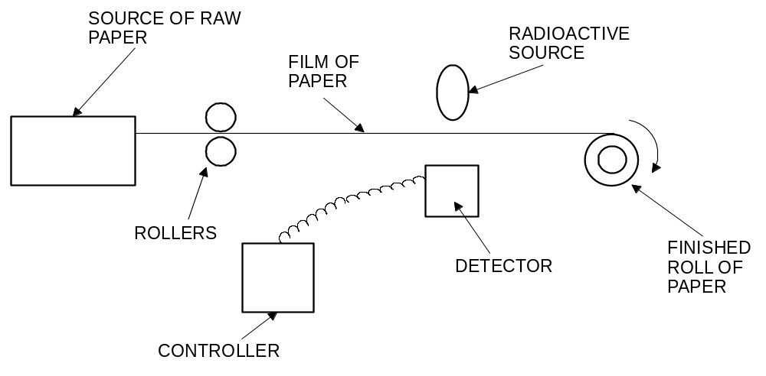
PAPER MAKING PLANT

GEIGER COUNTER

(i) Why are beta particles more suitable than alpha particles or gamma rays for this job?
[2 marks] [2

The table shows the reading on the counter during 70 s.

times in seconds | 10 | 20 | 30 | 40 | 50 | 60 | 70
total count since the start | 50 | 100 | 150 | 195 | 235 | 275 | 315
count in 10 seconds | 50 | 50 | 50 | 45 | 40 | 40 | 40

(ii) Look at the table of results. What happened to the thickness of the paper? Explain. [2 marks]

(iii) The isotope used in the above process has a half life of 5.50 years. If a new sample of the isotope used has a count rate of 1500 counts per minute and is only useful with count rate over 190 counts per minute, approximately how long will the isotope sample last before it needs to be replaced? [2 marks]

END OF SECTION B

Section C: Comprehension 11% [12 Marks)]
This section contains one (1) question. You must answer this question. Write your answers in the spaces provided. You are reminded of the need for clear and concise presentation of answers, and the use of specific physics terminology and laws/principles. Diagrams (sketches), equations and /or numerical results should be included as appropriate.
Suggested working time: 17 minutes.
_________________________________________________________________________
15. Sudden Stop

Vehicles are not intrinsically dangerous: let's face it, you are most unlikely to have an accident if your car never leaves your driveway! Which tends to prove that it is the movement that causes all the problems. You see, as soon as your vehicle moves, it comes under the influence of a variety of physical forces, some good for you, some bad. Things like momentum, impulse, kinetic energy, forces, gravity, friction, etc.

The worst of that lot is kinetic energy, a function of the speed and loaded mass of the vehicle. This kinetic energy increases proportionally with the square of your speed. In other words, when you triple your speed (for example when you go from 30 km/h to 90 km/h) your kinetic energy increases
9 times (3x3). This is not good because your braking distance will increase 9 times when you increase your speed 3 times. (Please note that I am not talking about the total stopping distance, as this would include the driver's thinking distance).

You probably realise what this means in practical terms: if you hit at 90 km/h the crash is going to be 9 times worse than it would be at 30 km/h. However if you take this a bit further, you will see that something good comes out of it. If faced with any crisis, wipe as much speed off the car as you can. So, you see that firstly (before taking evasive action with the steering wheel), you have to decrease your speed as much as you can - without locking the wheels.

Once you have reduced your speed, you must try to avoid a ‘hard landing’. It is the sudden stop which is the killer. Given a choice, a clump of bushes is preferable to a parked car, and hitting the back of a parked car is much better than hitting a brick wall. Above all, never hit a tree!! They have almost no ‘give’ (i.e. they are solid, and do not bend or spring much when hit). Worse, they also concentrate the whole force on a narrow area.

It’s also very important that your loads, especially heavy bags and luggage in the back seat, are securely tied down. The baby must be in the baby capsule on the back seat, and you and your passengers must be wearing seatbelts at all times.

Questions
a) Explain why the sudden stop a collision is a killer. [2 marks]

b) Use at least one formula to prove that "stopping distance increases 9 times when the speed increases 3 times". (Assume that the braking force is constant.) [2 marks]

c) What does "driver thinking time" have to do with the total stopping distance in a collision? [2 marks]

d). It says in the article that “hitting the back of a parked car I better than hitting a brick wall”. Explain, using physics terms and principles, why it is better to hit a parked car than a brick wall or a tree. [2 marks]

e) Again using physics terms and principles, explain why loads like bags and luggage should be secured (tied down) in a moving vehicle.

f). Explain how design features such as “crumple zones” use the concept of impulse to reduce the severity of injury to drivers in the event of a collision. [2marks]

END OF EXAM

Additional working space
Additional working space
Additional working space

